SIT 218/738: Secure coding

**Pass task 8.3D: Authorisation and Spring security**

**Overview**

An extended examgeneration app is provided to you. You need to incorporate the following features in it.

You have been provided a changed home page you need to change the flow of the application such that home page is displayed to all the users without any login required.



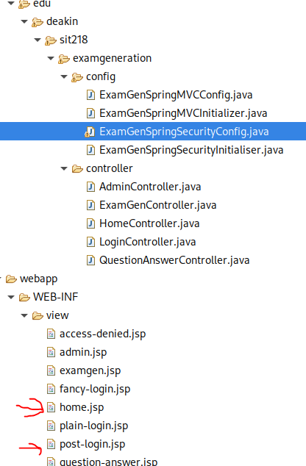

There is a login button on the page and when users clicks on it, you will should show the login page and then land on the post-login.jsp page. Make appropriate changes to HomeController and filters in ExamGenSpringSecurityConfig to allow users to access the home page first and then login using the login button.

**Submission Requirements:**

Submit one PDF file containing the following information:

1. Screenshot and updated filter.
2. Screenshot of required access control working on the application.

**Submission Due**

The due for each task has been stated via its OnTrack task information dashboard.